ORGANISATION OF DATA
Classification of Data: Classification is the process of arranging data into sequences and groups according to their common characteristics or separating them into different but related parts.
Ojectives of Classification:
- To simplify and condense the mass of data
- To explain similarity and dissimilarity of data
- To facilitate comparison
- To study relationships
- To prepare the data for Tabulation
- To present a mental picrture
Feature/ Requisites of Good Classification
- Suitability
- Unambiguous
- Exhaustiveness
- Flexibility
- Mutually Exclusive
- Stability
- Homogeneity

Methods of classification

- Chronological classification
- Geographical classification
- Qualitative classification
- Quantity talk
Variable :
Variable refers to the quantity or attribute whose value varies from one investigator to another.

Difference between Discrete Series and Continuous Series
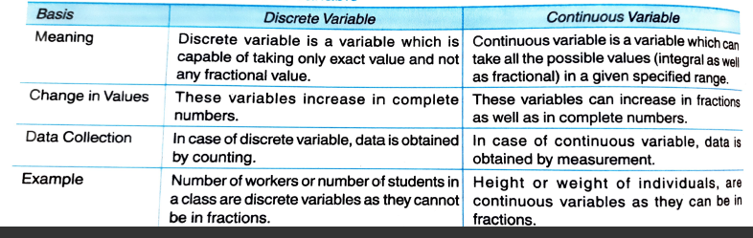

Frequency:
It refers to the number of times a given value appears in the distribution.
Statistical Series:
The arrangement of classified data in some logical order, like size, time of occurrence, or some other measurable and non measurable characteristics, is known as Statistical Series.

